

**LONGFORD COUNTY COUNCIL**

**COMHAIRLE CHONTAE AN LONGFOIRT**

**Minutes of September Monthly Meeting of Longford County Council**

**held in the Council Chamber, Aras an Chontae, Great Water Street, Longford on**

**Wednesday, 10th September 2014 at 4.00 p.m.**

**PRESIDING**: Councillor Mark Casey, Cathaoirleach.

**MEMBERS PRESENT**: Councillors – Paraic Brady, John Browne,

Seamus Butler, Mick Cahill, Micheál Carrigy,

Gerard Farrell, Padraig Loughrey,

Luie McEntire, Martin Mulleady, Colm Murray,

Pat O’Toole, Peggy Nolan, P.J. Reilly, Paul Ross

and Gerry Warnock.

**IN ATTENDANCE:**  Mr. Tim Caffrey, Chief Executive.

**APOLOGY:** Councillors John Duffy and Mae Sexton.

**MEETINGS**

**ADMINISTRATOR**: Ms. Anne Lee.

**VOTE OF SYMPATHY.**

On the proposal of Councillor S. Butler seconded by Councillor M. Carrigy, it was unanimously resolved that a vote of sympathy be extended to Mrs. Kathleen Reynolds and the Reynolds family on the death of her husband and former County Councillor, T.D. and Taoiseach, Albert Reynolds, and that the September Monthly meeting be adjourned as a mark of respect.

All members of the Council associated themselves with the vote of sympathy and many tributes were paid to Albert Reynolds.

The members spoke regarding Albert’s role in the peace process, his achievements in politics and business and, especially, his devotion to his wife and family.

Mr. T. Caffrey, Chief Executive, on his own behalf and on behalf of the staff of the County Council associated himself with the vote of sympathy.

The members agreed that an appropriate memorial to Albert Reynolds be considered by the Council.

A silent prayer was said for Albert.

It was agreed that theAdjourned Meeting take place on **Wednesday, 17th September 2014**

**at 4.00 p.m.**

This concluded the business of the meeting.

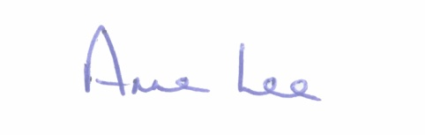

**Signed: _______________**

**Anne Lee,**

**Meetings Administrator.**

**Confirmed and adopted at Monthly Meeting of Longford County Council held on the**

**8th October 2014.**

**Signed: _______________**

**Cathaoirleach.**